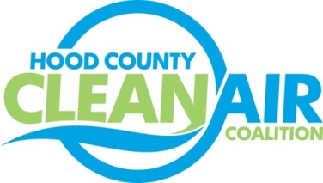
Meeting: Thursday, November 3, 2016
Neely House
304 East Rucker Street, Granbury, Texas 76048
8:30-10:00 a.m.

Agenda

- Call Meeting to Order
- EPA Updates – Randy Pitre
- Regional Updates – Michelle McKenzie
  - Feedback Requested About Fleet Alternative Fuel Vehicle Obstacles and Procurement Plans Until the End of the Year: https://www.surveymonkey.com/r/FleetsFortheFuture
  - Air Quality Funding Opportunities for Vehicles
    - TERP Schedule
    - EPA School Bus Rebate
  - TCEQ Proposed Ozone Classification
  - New DFW Clean Cities Videos
    - Idling: https://vimeo.com/164776346
    - NDEW: https://vimeo.com/185357502
  - Upcoming Training Schedule
  - DFW Clean Cities Annual Meeting: December 6th, 1:30 PM, NCTCOG offices (www.dfwcleancities.org for details)
  - DFW Clean Cities Sponsorship Opportunities
- Outreach Survey Report – Andrea Thomas, National Service Research
- Local Updates – Michelle McKenzie
  - Review of October Meeting Summary
  - Review of Projects
    - Monthly Budget Review for August
    - Status of Projects FY 16/17
  - Reports
    - October Ozone Update
    - Granbury Chamber IGC Meeting
5.) Discussion
6.) Adjourn

